Fascinating Turkey; Magical Istanbul and Captivating Cappadocia, Land of Fairy Chimneys
Sunday October 25th through Friday October 30st, 2015 – SPECIAL OFFER!
Hosted by Ozlem Warren; Turkish Culinary Expert and Author of Ozlem’s Turkish Table (www.ozlemsturkishtable.com)
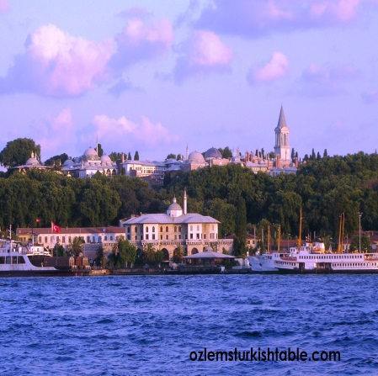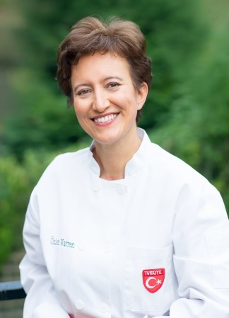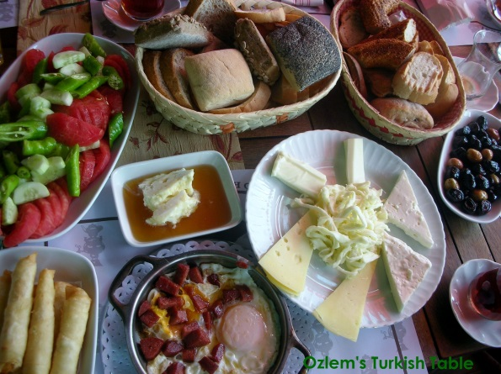
Please join us at our tailor made, small size boutique tour to explore my homeland, fascinating Turkey together. I am delighted to host this exciting tour, covering off the beaten track sights, experiencing foodie heaven markets in Istanbul, private boat tour along the Bosphorus, Whirling dervish shows, exploring old and new parts of Istanbul to give you a real feel of this fascinating city. And food, the glorious Turkish food; starting from my favorite meal of the day Turkish breakfast, every meal will be authentic and memorable. You will also enjoy and discover authentic Turkish cuisine with our Turkish cookery classes and learn how to make this wonderful cuisine. Cappadocia Region, the land of fairy chimneys will be a special highlight. Exploring Goreme Underground City, optional hot air balloon tour over the fairy chimneys, visiting a local Turkish Ceramic Art Shop to learn how the world famous tiles and ceramics made and watch masters working, visiting traditional Cappadocian home to experience local cuisine and many more – all to look forward to. We will be staying at charming, boutique hotels with warm Turkish hospitality for 5 nights.
Special Offer: 1,850 USD or 1,200 GBP (per person sharing in double room)
Single Supplement: 410 USD or 265 GBP
Tour Includes:
Accommodation (bed and breakfast) for 5 nights in boutique hotels, All museum entrances,
All internal flights in Turkey, VIP minibus ground transportation for 16 people, Welcome dinner and Farewell Dinner, 2 Turkish cookery classes, learning 2 different regional cuisines (Istanbul and Cappadocia for Anatolian cuisine), All airport transfers, All guide services, Private Bosphorus boat tour in Istanbul and cocktails.

Not included in the tour:
Your international return flight to Istanbul and Visa (if needed), personal expenses, extra drinks and mini bar at the hotels, drinks at meals. Single supplement if requested. Whirling dervish show and Turkish folk night, optional air balloon in Cappadocia, lunches and 2 dinners in Cappadocia. Gratuities for our guide and driver would also be most appreciated.
Fascinating Turkey; Magical Istanbul and Captivating Cappadocia, Land of Fairy Chimneys
Sunday October 25th through Friday October 30st, 2015
ITINERARY
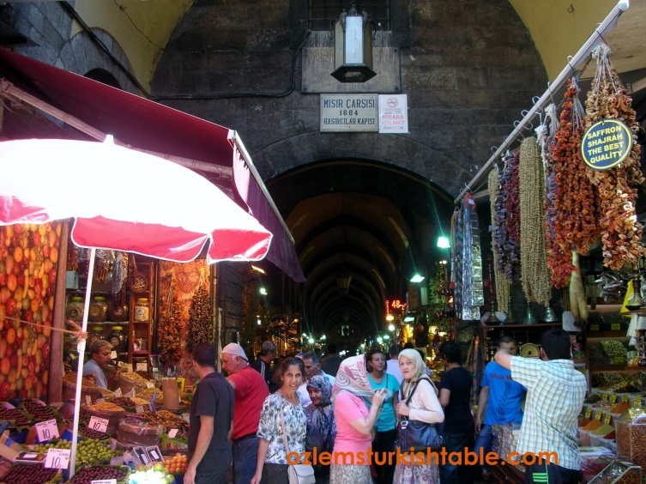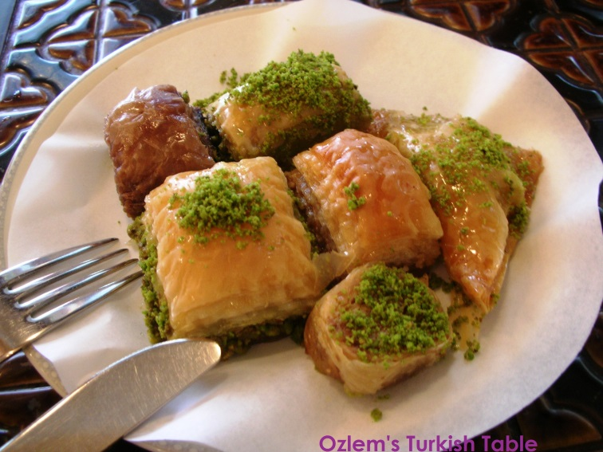

October 25th, Sunday: Arrival to Istanbul Ataturk International Airport (your arrival time is important to shape the activities of that day), transfer from the airport and check in to our charming Hotel Armada at the heart of Old Istanbul, Sultanahmet. Orientation tour in Sultanahmet, Old Istanbul. You may like to indulge in the famous Turkish Bath at the superb Kilic Ali Pasa Hamami (optional/extra; www.kilicalipasahamami.com). Private boat cruise along the Bosphorus to enjoy the beauty of Istanbul stretching to two continents. Welcome Dinner at the atmospheric Armada Hotel Terrace to enjoy delicious Turkish mezzes and kebabs overlooking the beautiful Old Istanbul and the Sea of Marmara.

October 26th, Monday: Leave hotel at 9 am after our delicious Turkish style breakfast and start exploring the fascinating Istanbul. We visit the Blue Mosque, famous for its turquoise Iznik tiles and frescoes. We will then continue to the breathtaking Hagia Sophia, a pioneer of architecture and the largest church in the world prior to St. Peter’s in Rome. After visiting the atmospheric Basilica Cistern, we will head to Nakkas Textile & Rugs to see their extensive collections on beautiful Turkish rugs (and experience how world famous Turkish carpets are made, while having lunch), tile, ceramics, print & calligraphy collection. Next stop is the magnificent Spice Market, to learn about and stock up on spices, Turkish delight, Turkish coffee and more. After all that festivity, we will take you to the New Town, Galata, Pera and Beyoglu area to introduce a different, another vibrant part of the city with its markets, passages, shops, mosques and sights. In the evening at 6.30 pm, we have a hands on Turkish cookery class where we learn to cook a delicious 4 course Turkish meal together and enjoy at the end.

October 27th, Tuesday: Check out from Hotel Armada and transfer to the airport to fly to Kayseri, Cappadocia region, land of fairy chimneys. Check in to our charming, beautifully decorated Peri Masali Cave Hotel http://www.perimasalihotel.com/ with its rooms craved through hundreds of years and delicately restored with stones. Orientation tour and lunch to follow. Then visit to Goreme Underground City and Goreme Open Air Museum. Dine at local restaurant and learn about local regional cuisine during our meal.

October 28th, Wednesday: Scrumptious Turkish breakfast at our hotel to enjoy regional delicacies. Optional hot air balloon tour in the early morning, starting at 5 am (extra). At 9.30am visit a local Turkish Ceramic Art Shop to learn how the world famous tiles and ceramics made and watch masters working. Then we will visit a traditional Cappadocian home and will be treated to a special local Turkish cookery class by the village ladies who will teach the local cuisine of Cappadocia as well as other delicacies. Our day will end around 4 pm, giving you a chance to rest in your hotel or enjoy a Turkish Bath. Evening dinner with optional special Turkish Night to enjoy Folkloric Dances from various regions and live music with refreshments.

October 29th, Thursday: Early morning check out and transfer to the airport to fly to Istanbul and check in to Hotel Armada. Free time; perhaps a visit to Grand Bazaar for last minute souvenirs, we will gladly accompany you for this trip. As an alternative, visit the foodie heaven Kadikoy Market in the Asian side and lunch at Ciya Restaurant, famous with fine example of regional Turkish cuisine. Farewell Dinner at the Khorosani Restaurant.

October 30th, Friday: Check out from our hotel and transfer to the Ataturk International Airport for the return flight.

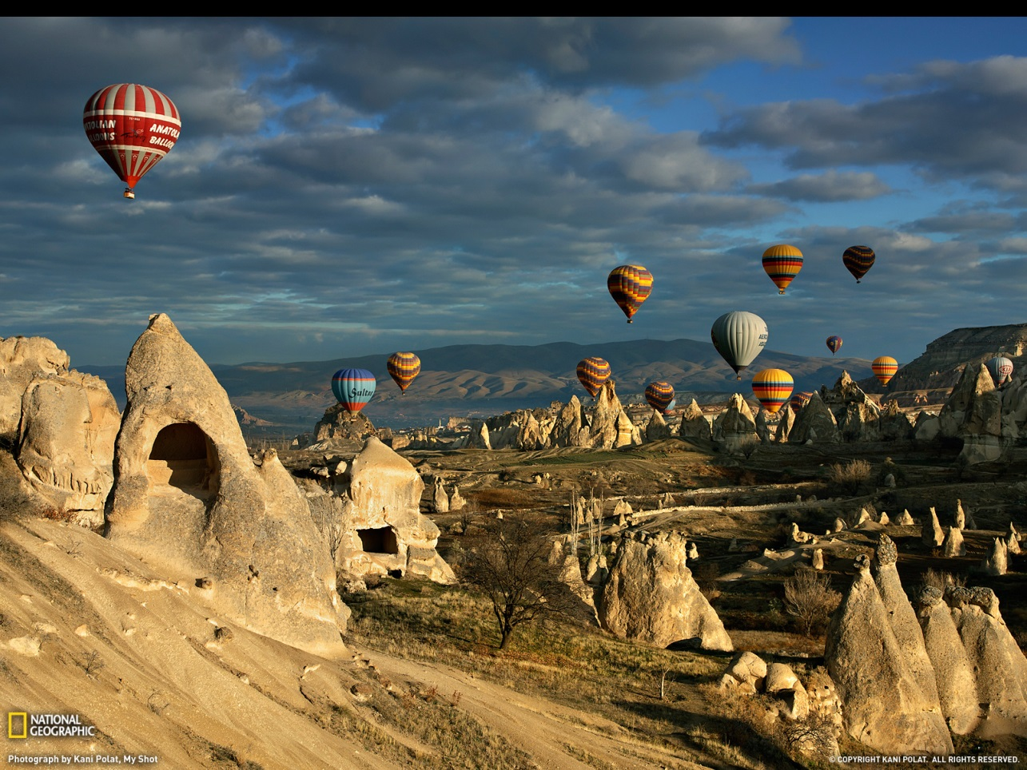

About Your Host….Ozlem Warren
Ozlem Warren is a native of Turkey, extensively travelled and lived in different parts of Turkey for 30 years. Ozlem is a passionate cook, international cookery teacher, traveler and host; she has been organizing culinary and cultural tours to Turkey for 8 years. She lives in Great Britain with her family and teaches Turkish cooking classes internationally, in Great Britain, at Central Market Cooking Schools in Texas – USA, in Jordan and in Istanbul, Turkey. Ozlem also publishes her Turkish recipes at her blog, Ozlem’s Turkish Table, www.ozlemsturkishtable.com. Ozlem would be delighted to have you on board to show you the fascinating land of Turkey from a local's perspective - a rare opportunity.
Fascinating Turkey Tour, Sunday October 25th to Friday October 30th, 2015
Registration Form

This bespoke culinary and cultural tour to Turkey is limited to 12 participants only and early booking is essential to guarantee spaces and availability for the desired hotels and internal flights. Total cost of tour per person is 1,850 USD or 1,200 GBP (per person sharing in double room) plus $ 50.00 non-refundable processing fee. Single Supplement is 410 USD or 265 GBP.

Cancellation policy: $50 USD non refundable processing fee; 45-31 days prior to departure 50% refundable; 30-0 days from departure 100% tour cost (no refund).
Please complete information below as it appears on your passport for Registration and email to Ozlem Warren at ozlem@ozlemsturkishtable.com at your earliest convenience.
NAME: _______________________________________________________________________________
Address: ___________________________________City: __________________ Country_______
Telephone: Business ___________________ Home _____________________
Email:___________________________
Exact Passport Name:_________________________________
Passport # : ________________________
Passport Expiration Date: ________________ Place of Issue_________________
Date of Birth:_______________
Traveling/Sharing With :_________________________________________________________
Bedding Preference: Twin ___________________ Double: _______________________
Domestic flight: Aisle _____________ Window _____________ Center _____________________
Frequent Flyer Nos_______________________________________________________________________________
Payment Information (Bank Transfer or PayPal Payment to Ozlem Warren) Or
Credit Card *: _____________________________________Exp. Date:__________
Name as is appears on Credit Card: _______________________________________________________
Billing Address of Credit Card: ___________________________________________________________
Signature: _____________________________________________
* There is a 3% transaction fee for all charges to Credit Cards. **Hotels are subject to availability according to the time of the booking. Your international return flight to Istanbul is not included in the price. Domestic flights in Turkey are included in the tour price and increase on airfare will be reflected. Trip insurance is recommended.

