Fascinating Turkey 2015—Istanbul, Cappadocia, Izmir, Ephesus, Sirince and More
Saturday May 23rd 2015 through Saturday May 30th 2015
Saturday October 24th through Saturday 31st, 2015
Hosted by Ozlem Warren; Turkish Culinary Expert and Author of Ozlem’s Turkish Table (www.ozlemsturkishtable.com)
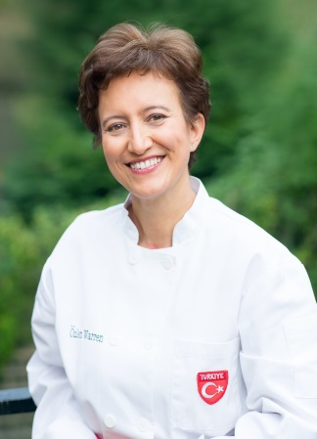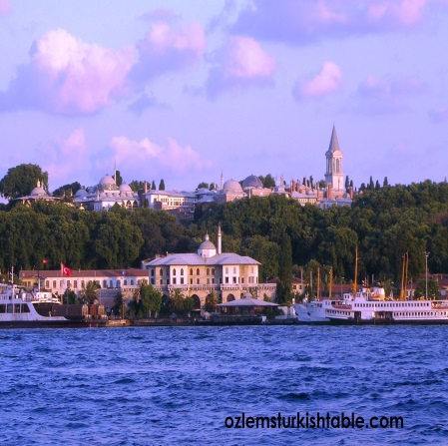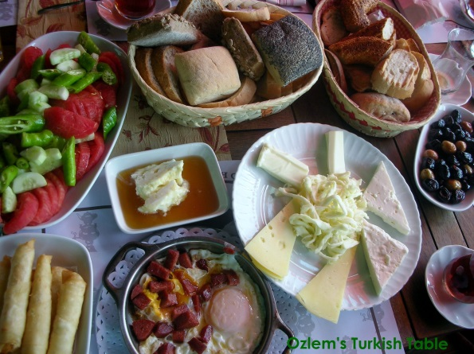
May 23rd, Saturday: Arrival to Istanbul Ataturk International Airport (your arrival time is important to shape the activities of that day), transfer from the airport and check in to our charming Hotel Armada at the heart of Old Istanbul, Sultanahmet. You may like to indulge in the famous Turkish Bath at the superb Kilic Ali Pasa Hamami (optional/extra; www.kilicalipasahamami.com). Welcome dinner at the atmospheric Hamdi Restaurant to enjoy delicious Turkish mezzes and kebabs overlooking beautiful Istanbul.

May 24th, Sunday: After the scrumptious Turkish style breakfast in our hotel, depart at 9 am to visit the Dolmabahce Palace (or Beylerbeyi Palace if preferred) with its great collections, then we will take our private boat along the Bosphorus for 2 hours to enjoy the beauty of Istanbul stretching to two continents. Visit the foodie heaven Kadikoy Market in the Asian side and lunch at Ciya Restaurant, famous with fine example of regional Turkish cuisine. If time allows, Fethi Pasa Korusu Gardens and have a lovely tea break. We will then head back to European side for a short walk; ,at around 5 pm, we will be back to the hotel. We planned to see the Whirling Dervish Show in a local Dervish Lodge in the evening. Evening dinner at the Khorosani Restaurant.

May 25th, Monday: Leave hotel at 9 am after breakfast and enjoy a short orientation tour in Old Istanbul. We will then visit the magnificent Spice Market, to learn about and stock up on spices, Turkish delight, Turkish coffee and more. Then we will head to Nakkas Textile & Rugs to see their extensive collections on beautiful Turkish rugs (see how world famous Turkish carpets are made, while having lunch), tile, ceramics, print & calligraphy collection. After all that festivity, we will take you to the New Town, Galata, Pera and Beyoglu area to introduce a different, another vibrant part of the city with its markets, passages, shops, mosques and sights. In the evening at 6.30 pm, we have a hands on Turkish cookery class where we learn to cook a 4 course Turkish meal together and enjoy at the end.

May 26th, Tuesday: Check out from Hotel Armada and transfer to the airport to fly to Kayseri, Cappadocia region, land of fairy chimneys. Check in to our charming, authentic hotel Queens Cave Hotel in historical Ortahisar town, with its rooms craved through hundreds of years and delicately restored with stones; they have a wonderful terrace and green garden where they have organic produce, homemade regional jams and more. Orientation tour and lunch to follow. Then visit to Goreme Underground City and Goreme Open Air Museum. Dine at local restaurant and learn about local regional cuisine during our meal.

May 27th, Wednesday: Scrumptious Turkish breakfast at our hotel to enjoy regional delicacies. Optional hot air balloon tour in the early morning, starting at 5 am (extra). At 9.30am visit a local Turkish Ceramic Art Shop to learn how the world famous tiles and ceramics made and watch masters working. Then we will visit a traditional Cappadocian home and will be treated to a special local Turkish cookery class by the village ladies who will teach the local cuisine of Cappadocia as well as other delicacies. Our day will end around 4 pm, giving you a chance to rest in your hotel or enjoy a Turkish Bath. Evening dinner at our hotel, followed a special Turkish Night to enjoy Folkloric Dances from various regions and live music with refreshments.

May 28th, Thursday: Early morning check out and transfer to the airport to fly to Izmir. We will visit head to charming Sirince Village for our hands on Turkish cookery class, this time to learn about the Aegean cuisine, use of the regions produce, olive oil to prepare 4 course meal together. Then we will visit the fascinating, ancient Greco – Roman city, Ephesus. Check in to our charming Markiz Hotel in Sirince, packed with regional character at 6 pm. Evening dinner at our hotel.

May 29th, Friday : Turkish breakfast at our hotel and depart at 8 am and visit Virgin Mary’s House and the local leather shop to view their collection. We will take the noon flight from Izmir to Istanbul and check in to our Hotel Armada in Istanbul. Meet at 8 pm k at the reception to go to our Gala Dinner at the atmospheric Kumkapi district with live music, at Okyanus Balik Restaurant specializing in fish, hot and cold Turkish mezzes as well as meat courses on request.

May 30th, Saturday: Free time (perhaps a visit to Grand Bazaar for last minute souvenirs, we will gladly accompany you for this trip if you’d like) and check out to transfer to the Airport for return.

Fascinating Turkey Tour, May 23rd-30th and October 24th - 31st 2015
Registration Form (2 pages)

This bespoke culinary and cultural tour to Turkey is limited to 15 participants only and early booking is essential to guarantee spaces and availability for the desired hotels and internal flights. Total cost of tour per person is $ 3,050.00 plus $ 50.00 non-refundable processing fee; the cost is based on double occupancy. Single Supplement: $ 600. The tour includes: Accommodation (bed and breakfast) for 7 nights in boutique hotels, all museum entrances, all internal flights in Turkey, VIP minibus ground transportation for 16 people, 6 lunches, 6 dinners, 3 Turkish cookery classes, learning 3 different regional cuisines (Istanbul, Cappadocia for Anatolia cuisine and in Sirince for Aegean cuisine), gratuities, all airport transfers, all guide services and private Bosphorus boat tour in Istanbul and cocktails, Whirling dervish show and Turkish folk night.
Not included in the tour: Your international return flight to Istanbul and Visa (if needed), personal expenses, extra drinks and mini bar at the hotels, drinks at meals, Single supplement of $ 600 if requested.

Payment Details: $ 1,550 deposit due with registration (includes $ 50 non-refundable registration fee). Remaning $ 1,550 is due by Friday, 27th March 2015 (for the May 2015 tour) and Friday, 4th September 2015 (for the October 2015 tour).
Cancellation policy: $ 50 USD non refundable processing fee; 45-31 days prior to departure 50% refundable; 30-0 days from departure 100% tour cost (no refund).
Please complete information below as it appears on your passport for Registration and email to Ozlem Warren at ozlem@ozlemsturkishtable.com at your earliest convenience.
Registration for (please tick): May 23rd-30th 2015 Fascinating Turkey Tour _________________
October 24th - 31st 2015 Fascinating Turkey Tour _________________
NAME: _______________________________________________________________________________
Address: ___________________________________City: __________________ Country_______
Telephone: Business ___________________ Home _____________________
Email:___________________________
Exact Passport Name:_________________________________
Passport # : ________________________
Passport Expiration Date: ________________ Place of Issue_________________
Date of Birth:_______________
Traveling/Sharing With :_________________________________________________________
Bedding Preference: Twin ___________________ Double: _______________________
Fascinating Turkey Tour, May 23rd-30th and October 24th - 31st 2015
Registration Form ; Continued

Domestic flight: Aisle _____________ Window _____________ Center _____________________
Frequent Flyer Nos_______________________________________________________________________________
Payment Information (Bank Transfer or PayPal Payment to Ozlem Warren) Or
Credit Card *: _____________________________________Exp. Date:__________
Name as is appears on Credit Card: _______________________________________________________
Billing Address of Credit Card: ___________________________________________________________
Signature: _____________________________________________
* There is a 3% transaction fee for all charges to Credit Cards. **Hotels are subject to availability according to the time of the booking. Your international return flight to Istanbul is not included in the price. Domestic flights in Turkey are included in the tour price and increase on airfare will be reflected. Trip insurance is recommended.
About Your Host….Ozlem Warren
Ozlem Warren is a native of Turkey, extensively travelled and lived in different parts of Turkey for 30 years. Ozlem is a passionate cook, traveler and host; she has been organizing culinary and cultural tours to Turkey for 8 years. She lives in Great Britain with her family and teaches Turkish cooking classes in Great Britain at Central Market Cooking Schools in Texas – USA and in Istanbul, Turkey. Ozlem also publishes her Turkish recipes at her blog, Ozlem’s Turkish Table, www.ozlemsturkishtable.com Ozlem would be delighted to have you on board to show you the fascinating land of Turkey from a local's perspective - a rare opportunity.

